My Shop

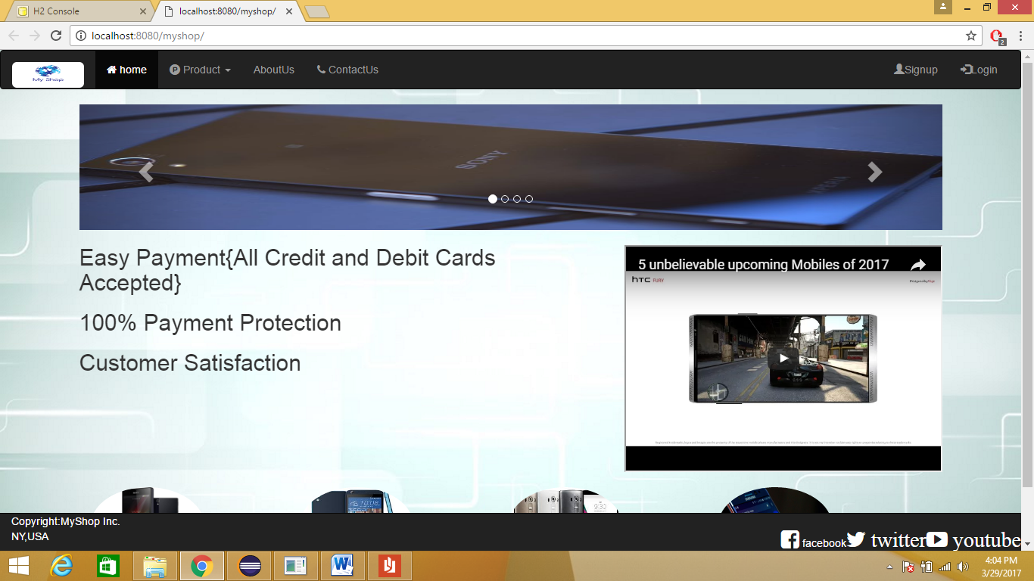

By: Sumeet

An Ecommerce portal developed exclusively for buying and selling of mobile phones and smartphones.

Index

1. Introduction.
2. Basic requirements.
3. System and Hardware Requirement.
4. Types of Users.
5. Home Page.
6. Signup Page.
7. Login Page.
8. Product Page.
9. Products Detail Page.
10. Admin Page.
11. Admin Product Page.
12. Cart Page.
13. Shipping Address Page.
14. Order Summary Page.
15. Thank You Page.

Introduction

E-commerce (electronic commerce or EC) is the buying and selling of goods and services, or the transmitting of funds or data, over an electronic network, primarily the internet.

The objective of this project is to develop a general purpose e-commerce store where mobile phones and smartphones can be bought from the comfort of home through the Internet. However, for implementation purposes, this project will deal with an online shopping for electronic projects. An online store is a store on the Internet where customers can browse the products and select products of interest. The selected items may be collected in a shopping cart. At checkout time, the items in the shopping cart will be presented as an order. At that time, more information will be needed to complete the transaction. Usually, the customer will be asked to fill shipping address. The order details along with order number is shown to the customer as soon as the order is placed.

Basic requirements to be fullfilled

* The application should be accessible over the Internet.
* The system should allow a customer to perform the following operations:
  + Browse the store to view products.
  + Add and remove products from an online shopping basket.
  + Place a shopping order by providing delivery information.
* The system should allow an authorized administrator to perform the following operations:
  + Add new products.
  + Edit information of products.
  + Delete products.
  + Update products
* To implement the features, the following specifications have been laid down to design My Shop application:
  + The application should be developed in Spring MVC and Hibernate
  + The design, layout, and navigation of the application should be uniform across all Web pages.
  + Shopping activities of customers should be tracked across a user's session through a shopping cart.
  + User authentication should be form-based.
  + User authorization should be role-based.
  + The data provided by the user must be validated.
  + The application should provide information on the company's profile and its contact details.

System and Hardware Requirements

Software Requirements

* Operating System: (Windows 7,8,10);
* Web Brower: Internet Explorer, Mozilla Firefox, or Google Chrome
* Drivers: Java Runtime Environment
* Integrated Development Environment: Eclipse, Apache Tomcat  
    
  **Supported architectures**

• 32-bit (x86)  
• 64-bit (x64)

**Hardware requirements**

• 1.6 GHz or faster processor

• 1 GB of RAM (1.5 GB if running on a virtual machine)

• 10 GB of available hard disk space

• 600 MB of available hard disk space (language pack)

• 5400 RPM hard drive

• DirectX 9-capable video card running at 1024 x 768 or higher display resolution

Types of Users

* Admin: The administrator is the owner of this application.
* The administrator can perform the following functions:
* Admin can add user, edit user information and can remove user.
* Admin can add products, edit product information and add/remove product
* Users: The users of this application are all customers who would shop using application. The users should be able to perform the following functions using this system:
* View, browse, and select a category on the home page.
* View, add, and update items in the cart.
* Delete items from the cart.
* Check out the items from the application or continue shopping.
* Sign-on/login using a username and password.
* Place the order by completing the order form

Home Page

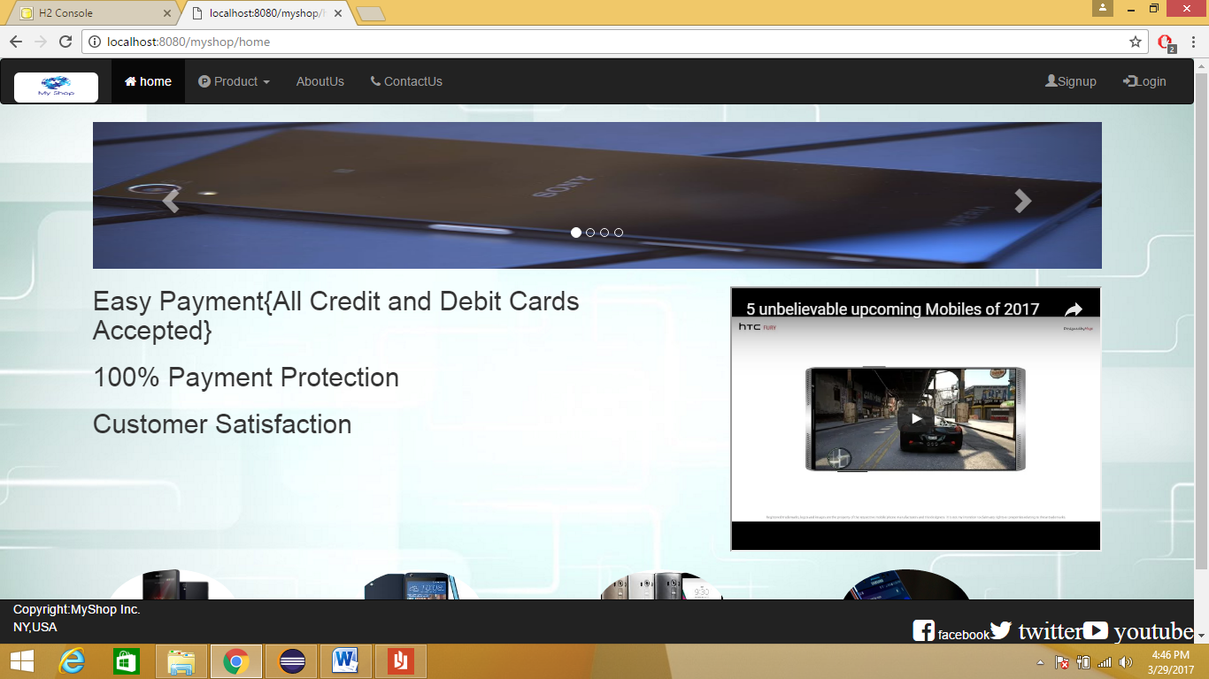

Home page containes embedded youtube video image carousel and images of different product categories.Once the user logs in home page with admin the page shows additional navigation links through which admin can perform various operations.

SignUp Page

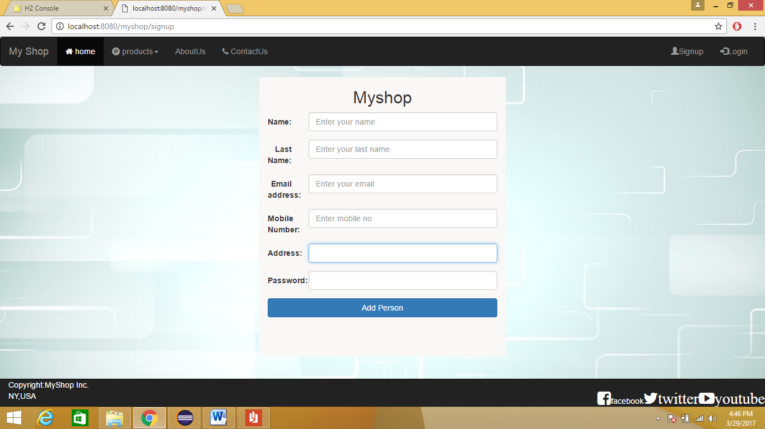

This page allow a new user to get registered with the site.

Login Page

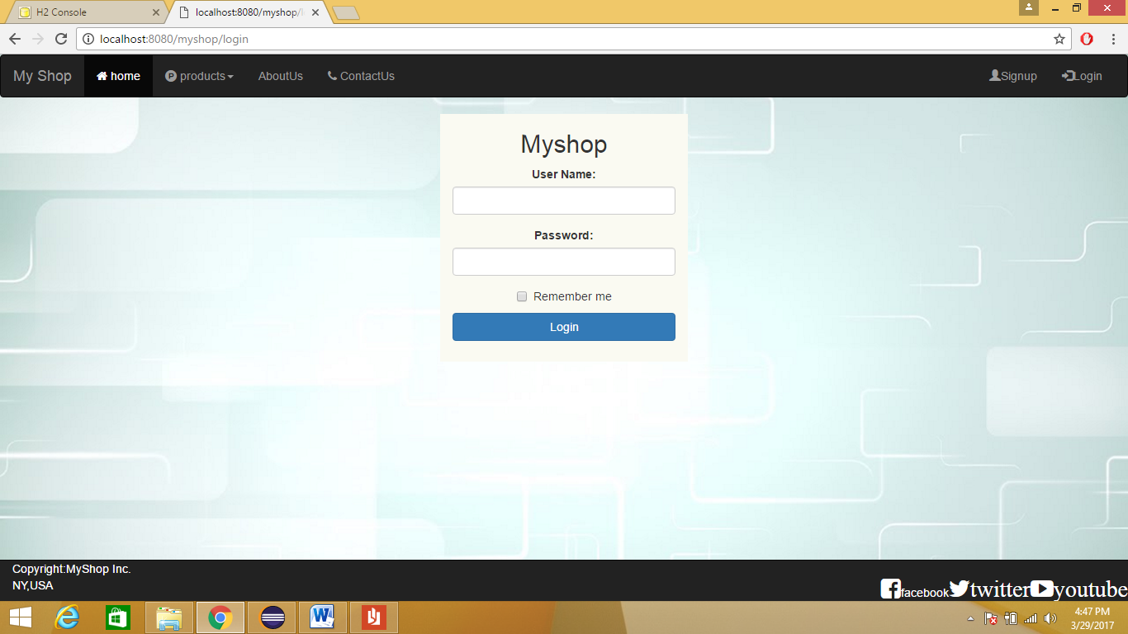Once the user get himself registered the user can login into site to do shopping.

This page is common for logging for both user and admin.

Product Page

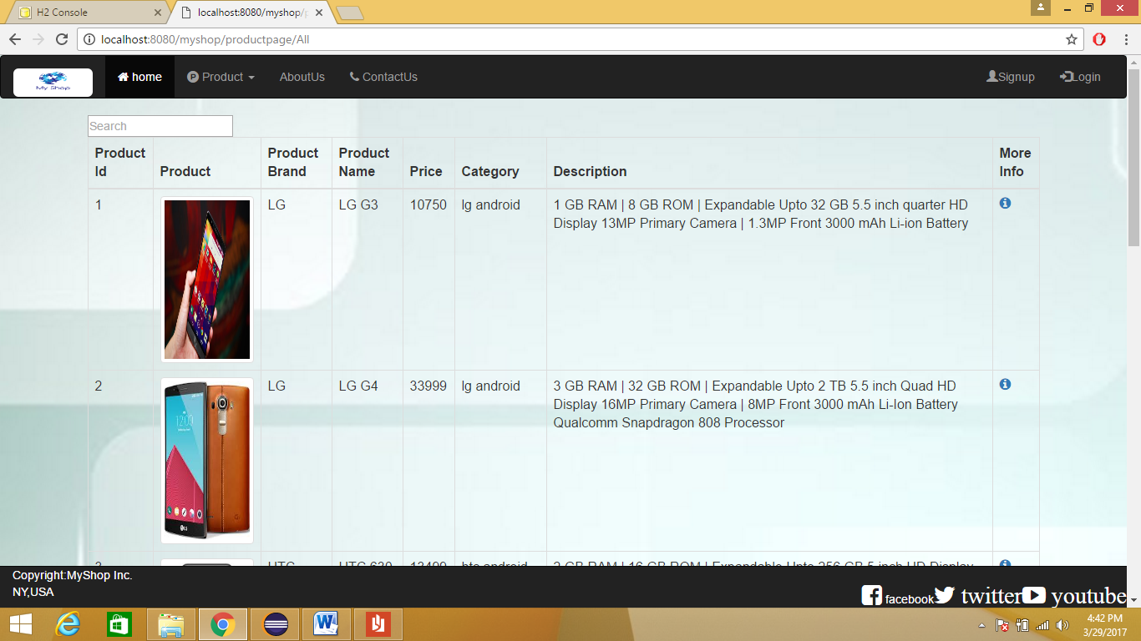

This page show information abouts available products.

ProductsDetails Page

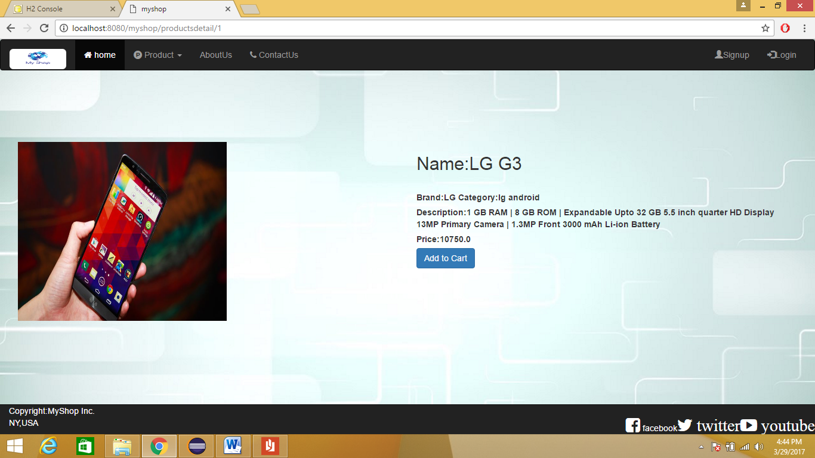

This page show detailed information about selected product and option to add it to cart.

Admin Page

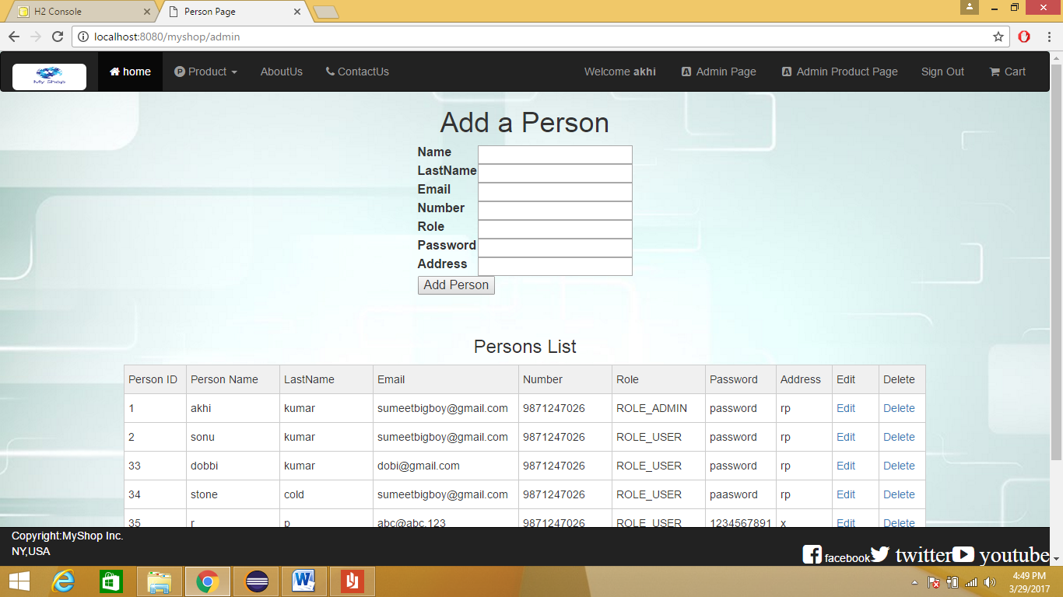

This page allow admin to add new admins or power to change any available details of a user.

Admin ProductPage

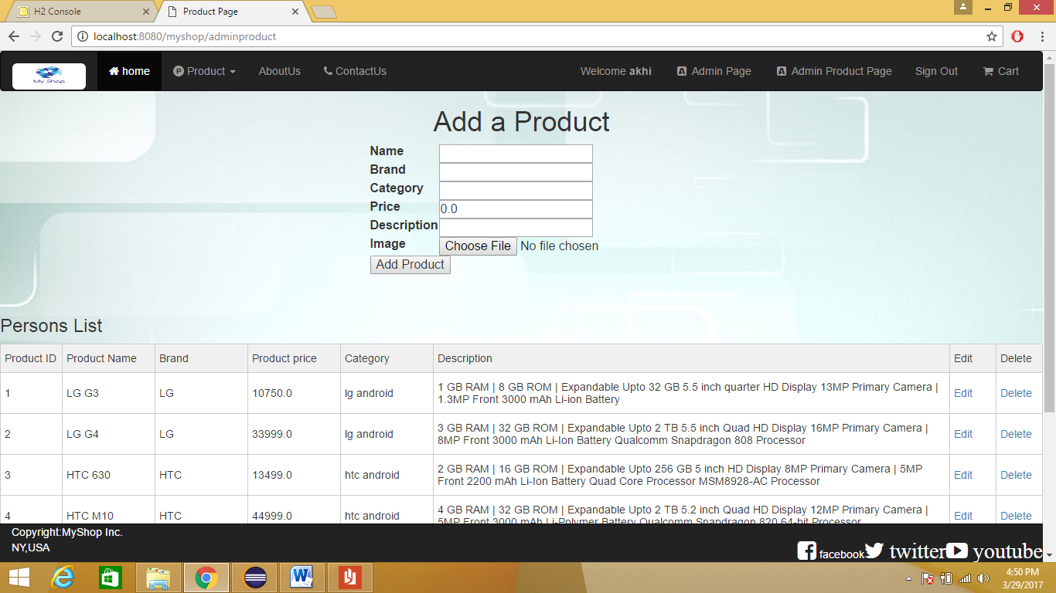

This page allow admin to add new Products as well as change details of products.

Cart Page

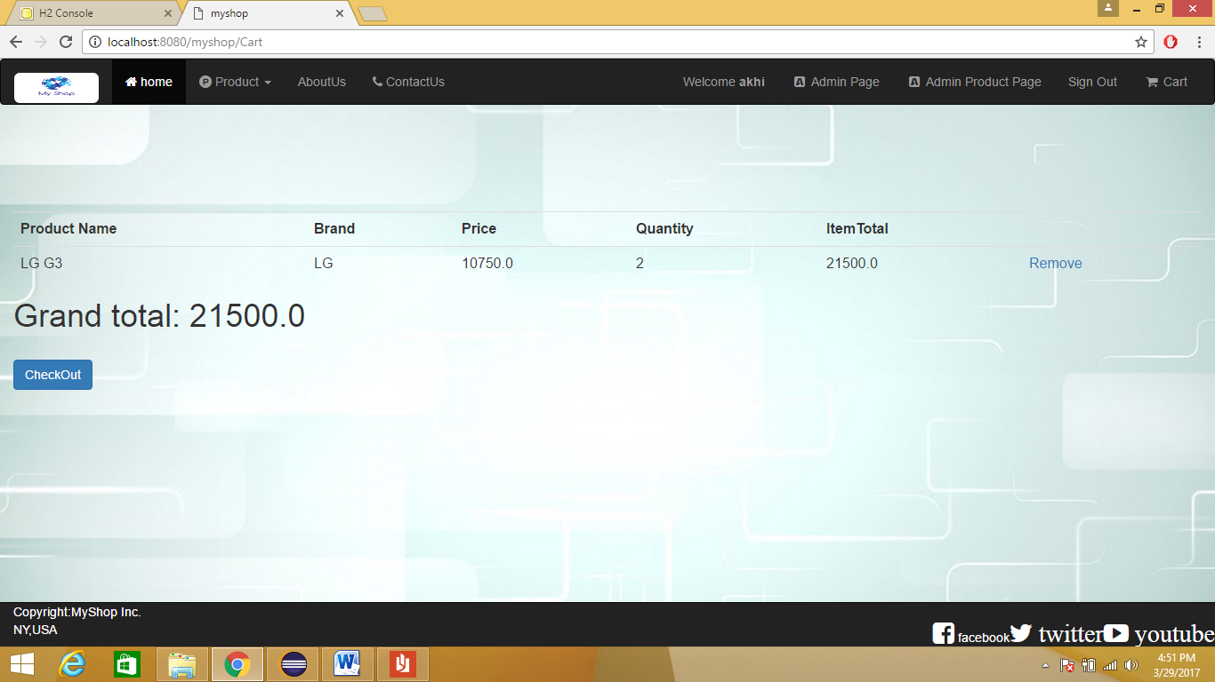

This page show the items of a user selected for purchase.

Shipping Address Page

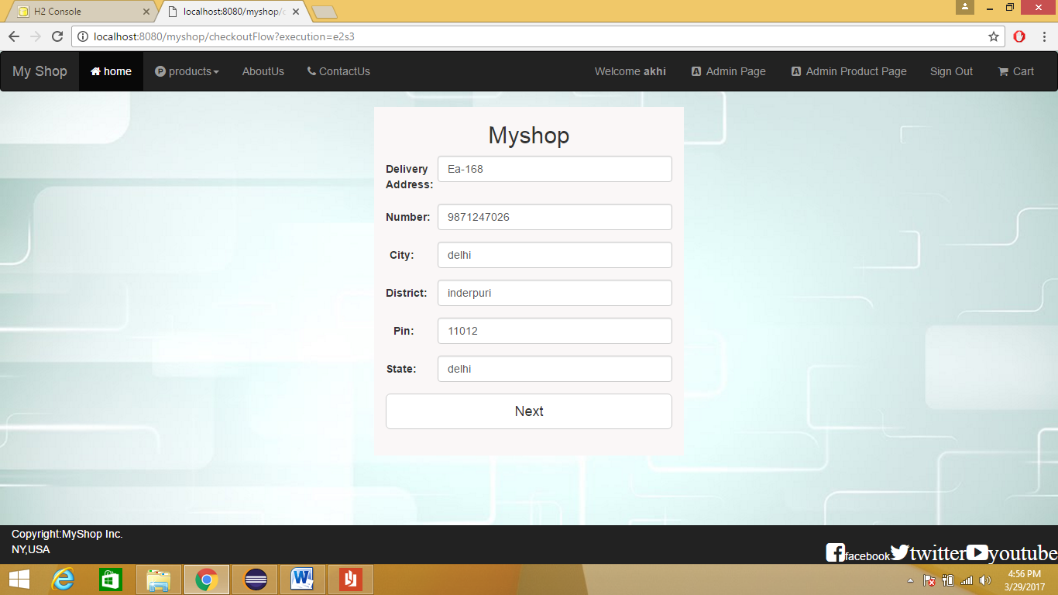

Shipping Address of the user is taken here

Order Summary Page

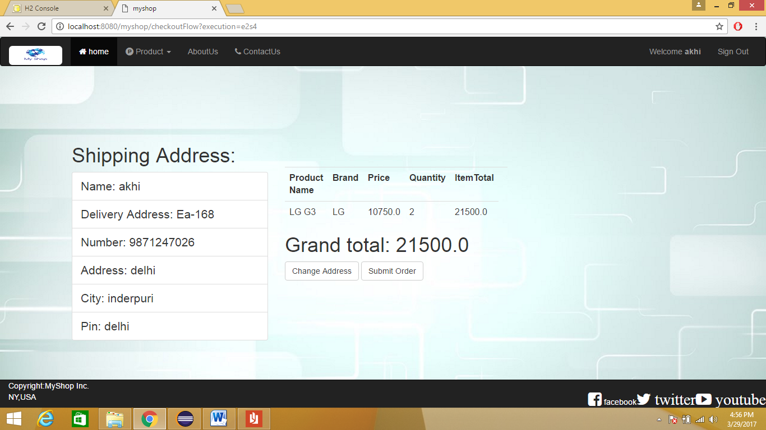

On this page, the details of user and order is shown and user can confirm order by clicking on Submit Order Button.

Thank You Page

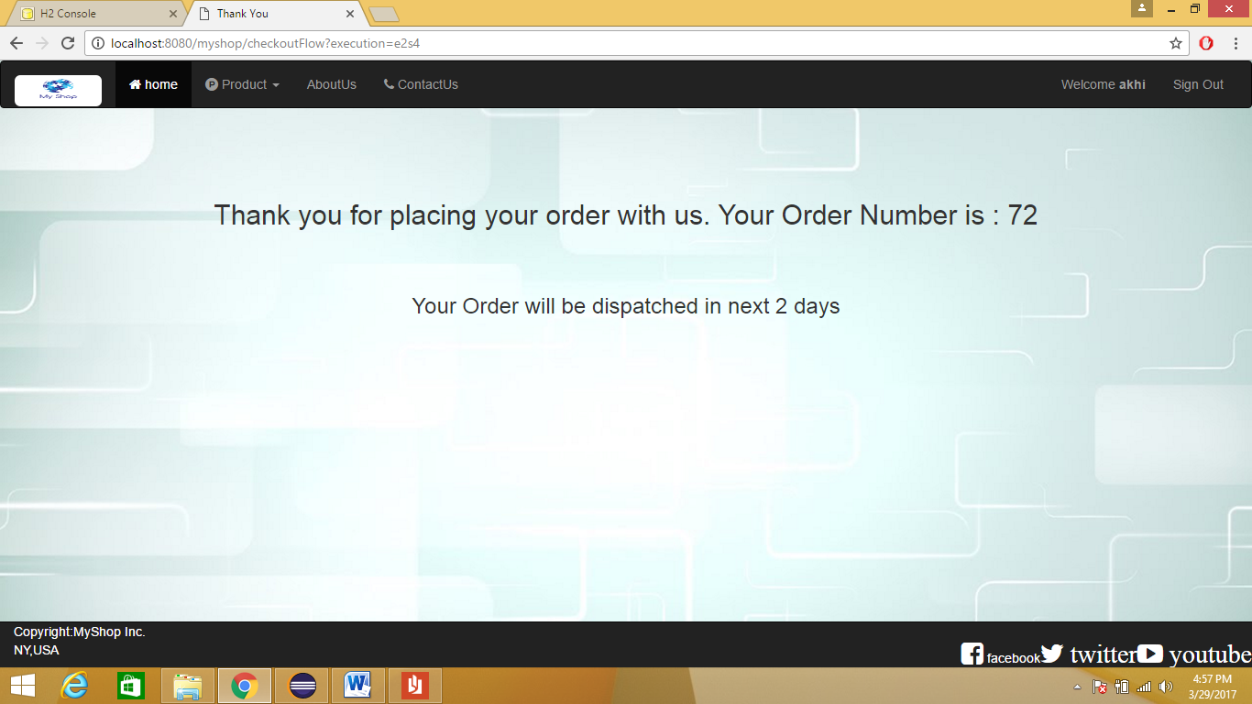This page display thank you message as well as order no of user.